Lighting

📘 Definition
# Source: AI Source: Provided by: [Data Path: Persons Table -> ID Column: 1, Name_En Column: Motasem Essam] -> From: [ChatGPT] on [5/2/2026]
Lighting is the use of light (natural or artificial) to make objects visible and to control how they look. In graphics, it refers to how light is simulated to make images or 3D scenes look realistic, clear, and detailed.

💡 Lighting in real life and graphics
# Source: AI Source: Provided by: [Data Path: Persons Table -> ID Column: 1, Name_En Column: Motasem Essam] -> From: [ChatGPT] on [5/2/2026]
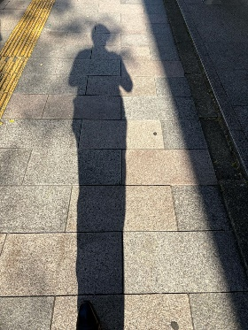
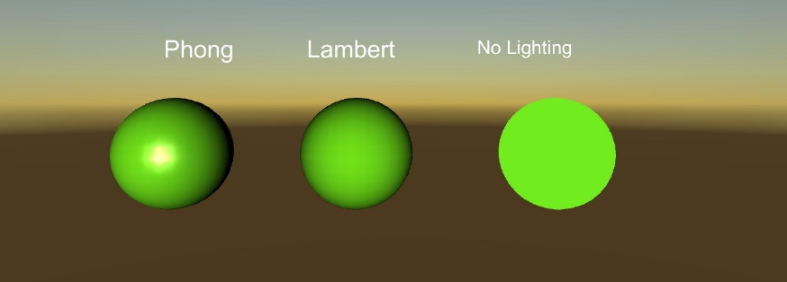
- In real life: sunlight, lamps, and shadows
- In graphics: simulated light created by computers

🧠 How lighting works in computer graphics
# Source: AI Source: Provided by: [Data Path: Persons Table -> ID Column: 1, Name_En Column: Motasem Essam] -> From: [ChatGPT] on [5/2/2026]
Lighting affects how we see objects by controlling:
- Brightness → how light or dark something appears
- Shadows → areas where light is blocked
- Highlights → shiny or bright spots on surfaces
- Depth perception → makes flat objects look 3D

🎯 Simple example
# Source: AI Source: Provided by: [Data Path: Persons Table -> ID Column: 1, Name_En Column: Motasem Essam] -> From: [ChatGPT] on [5/2/2026]
A ball in different lighting:
- ☀️ Bright light → looks clear and detailed
- 🌙 Low light → looks dark and less visible
- 💡 Side light → creates shadows and makes it look 3D

🎮 Where lighting is used
# Source: AI Source: Provided by: [Data Path: Persons Table -> ID Column: 1, Name_En Column: Motasem Essam] -> From: [ChatGPT] on [5/2/2026]
- 🎮 Video games (to make worlds look realistic)
- 🎬 Movies and animation (CGI scenes)
- 🧑‍🎨 Digital art and design
- 🏗️ Architecture visualization

🚀 In short:
# Source: AI Source: Provided by: [Data Path: Persons Table -> ID Column: 1, Name_En Column: Motasem Essam] -> From: [ChatGPT] on [5/2/2026]
Lighting = how light is used or simulated to make objects visible and realistic in real life or computer graphics.

